Digital Media Project



**SM6P07NI Digital Media Project**

**20% Research and Proposal**

**2021-22 Autumn**

**Student Name: Bibek Dhungana**

**London Met ID: 20049286**

**College ID: NP01MM4S210075**

**External Supervisor: Pooja**

**Internal Supervisor Rakshak**

**Assignment Due Date: Friday, December 17, 2021**

**Assignment Submission Date: Friday, December 16, 2021 Word Count: 2813**

*I confirm that I understand my coursework needs to be submitted online via Google Classroom under the relevant module page before the deadline in order for my assignment to be accepted and marked. I am fully aware that late submissions will be treated as non-submission and a marks of zero will be awarded.*

Abstract

Starting from the early ninetieth century, animation has been a forefront of children’s Entertainment. Most of the animations during those years were made with traditional methods, animations now are digital. Similar to how there have been drastic changes in terms of implementation, the output has varied as well but what still remains is the joy of witnessing something that you created, come alive. This project is a courtesy to the history of animation and how much I appreciate them. This report will contain my research on animation and the reasons as to why I chose to make an animation for my Digital Media Project

With the help of my supervisors, Rakshak sir and Pooja maam, I was able to finalize my concepts as well as my client for this project.

This is a coursework based on research..

**Table of Contents**

Section A: Research 1

1 Introduction 1

2 Research Process 2

3 Literature Review 3

3.1 Methods of Animation 3

3.1.1 Cel Animation (Traditional Animation) 4

3.1.2 2D Animation 4

3.1.3 3D Animation 5

3.1.4 Stop Motion Animation 5

3.2 Character Design 6

3.2.1 Shape Language 6

3.2.2 Design Silhouettes 6

3.2.3 Character Turnaround 7

3.2.4 Colour Palette 7

3.3 Animation Methods in 2D Animation 8

3.3.1 Pose to Pose Animation 8

3.3.2 Straight Ahead Animation 8

3.4 Merging 2D and 3D animation 9

4 Product Review 11

4.1.1 Majd and the Librarian 11

4.1.2 IRIS | Animation & Live Action 12

5 Summary and Conclusions 13

Section B: Project Proposal 14

1 Project Title 14

2 Research Question 14

3 Treatment 15

4 Resources 16

5 Contribution of Others 17

6 Evaluation & Testing 17

References and Bibliography 18

Appendix 20

**Table of Figures**

# Section A: Research

## 1 Introduction

A project's starting until its conclusion might be thought of as the beginning of a research project. A problem's evaluation is typically followed by the researcher developing a number of questions and objectives.

We were taught sketching and  2d animation during our first year of college because we belong to multimedia field. I have been excited by watching my creations animation ever since we got the opportunity to make animations during the second coursework of the Drawing  module.  
  
This is the reason why making an animation video was selected as the digital media project(DMP). We are expected to give this project our best effort because studying multimedia for the previous two years has taught us a lot.

With plans in place and expectations established, it is now necessary to prepare and present research on the particular topic to complete/finish the project, along with a few examples. With the help of the module teacher, I'm prepared to do my best in this project with all the effort.

## 2 Research Process

## Starting a project requires research since it is important to become familiar with the numerous principles, theories, and articles related to the project's required topic.

## Similar to how the researcher's list of potential research subjects and arrangement of those ideas in a diagram before beginning the project illustrates the search technique they employed.

**Concept**

**Gain Ideas,**

**Inspirations and Generate Questions**

**Start Pro**

**duct Review**

**Start Literature Review**

**Access Information on Answering the Questions**

**Plan on what to utilize**

**Implent the ideas an**

**d create plans**

*Figure SEQ Figure Figure 1: Example of a research process\* ARABIC 1: Research process that I*

## 3 Literature Review

### For this project, it is necessary to review and research a number of animation-related principles as well as a number of animation techniques and also the 3D animation software that can be used for the digital media project.

#### 3.1.3 3D Animation 3D animation is the technique of modeling and animating people or environments in a three-dimensional space using 3D design tools like Autodesk Maya, Blender, etc.

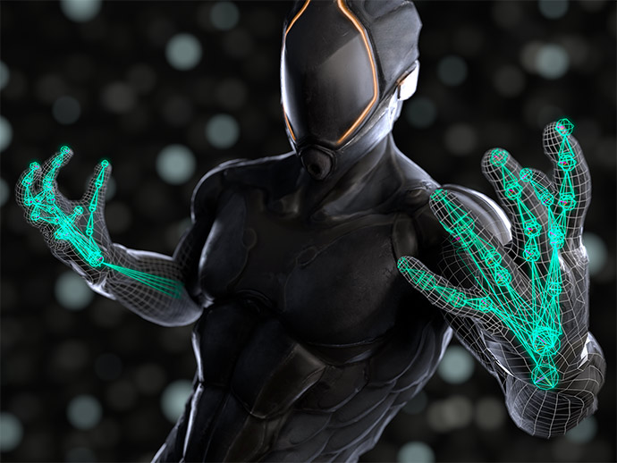

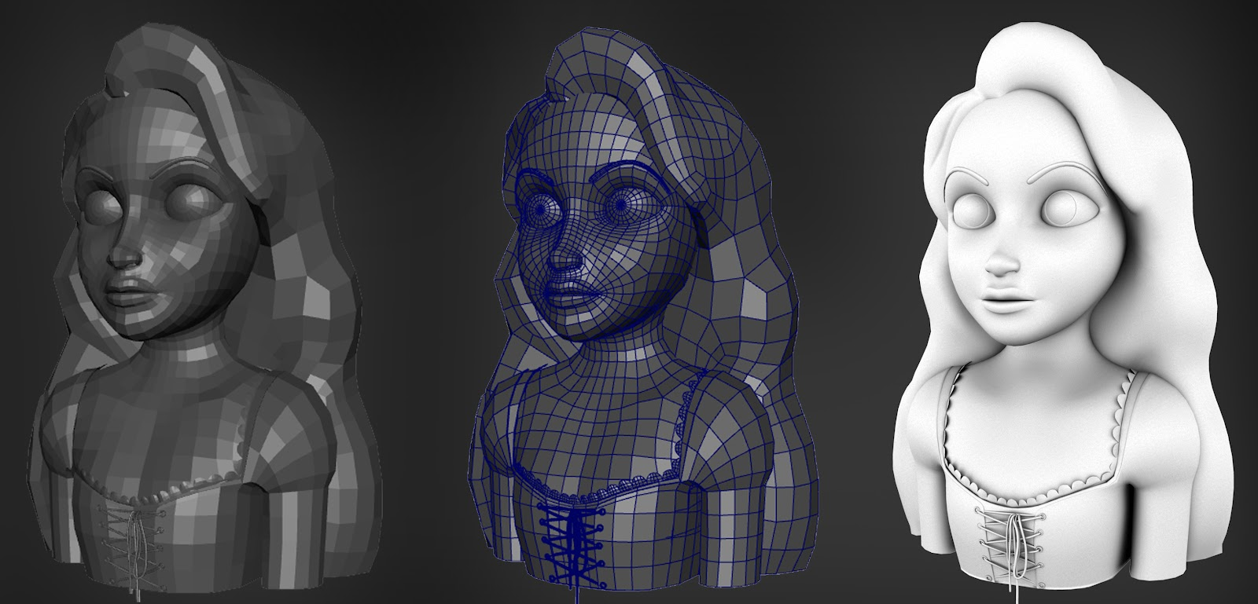

### 3.2 Sculpting vs Modeling. 1. Sculpting is better for organic modeling

As you might know, organic shapes meaning anything we find in nature whether it be, animals, trees and plants, rocks, mountains, and so on are needed many creative 3D projects.

While 3D modeling is great for creating hard surfaces like buildings, weapons, furniture, vehicles, gadgets, etc. it’s not the best for creating organic shapes.

Even though you can use traditional 3D modeling to that, I would say it’s not going to be a wise option, and it’s not going to be a smart use of your time, and effort because 3D sculpting is designed and was created in the first place to allow 3D artists to work on organic shapes.

### 2. They deal with a mesh differently

When you start sculpting something you are kind of morphing, shaping, extending, or cutting an already existing mesh with many thousands of polygons. While you do this you are moving, scaling, or rotating a bunch of polygons at the same time which makes the process smooth and fast.

On the other hand, modeling allows you to control individual polygons, vertices, or edges during the process of creating your 3D models, and what you create usually has to be created polygon by polygon but you can use Modifiers or addons to speed up the process.

### 3. 3D modeling vs sculpting in art skills

To be good as 3D sculpting artist or to create organic shapes using sculpting you will do better if you have a   
 background in art, or at least you need to understand and learn the fundamentals of art.

Fundamentals such as form and anatomy to be able to create realistic human beings, animals, or monsters for that matter. This knowledge is also necessary for 3D modeling but it’s not needed as much because modeling, for the most part, deals with surfaces that are not as fluid as organic surfaces.

For example, someone who has never been good as an artist can create a car wheel, a house, or a weapon that looks good compared to his first attempt at sculpting.

### 

Since my work mainly is focused on Environment I have to focus more on sculpting in my project.  
Also I should be focusing on modeling for a particular model in the environment.   
   
One of the reasons that allows sculpting to be a better medium to show your creativity while creating organic shapes whether it be creating human beings, animals, monsters, or natural scenes is the huge number of polygon count it requires to do so.

## 3.2 High Poly Modeling of environment.

In the real world, High Poly 3D modeling is essential when your users need photorealistic representations of objects or the ability to zoom in on specific features. This could translate into a variety of uses, where Low Poly techniques aren't sufficient.

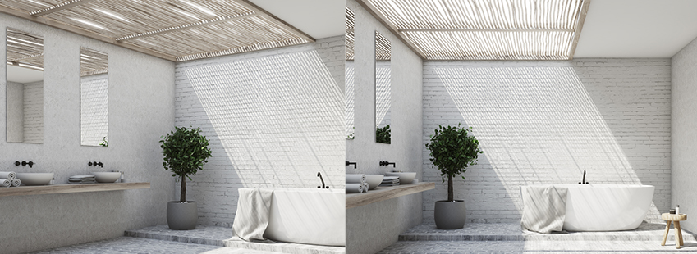

**High Poly modeling is a great solution when accuracy and visual richness are a priority and interactivity is less important**.

It's also a handy technique when we have a small batch of assets to model, and the price isn't the sole factor. If you want the highest possible fidelity 3D models, maxing out on the polygon count will be worth the price.

## 3.3 Low Poly Modeling of environment.

The opposite applies when we think about Low Poly modeling use cases. Low polygon modeling is more suited to situations where users need to move and interact with 3D objects and where visual detail is lower down the list of priorities.

As we've seen, **Low Poly models are great for situations where interactivity and speed are crucial**, while **High Poly models are ideal when detail is all-important**. However, each project is unique, and polygon counts differ greatly based on model complexity, so it's essential to find a level of detail that works for you.

It's also vital to work with modelers who know how to use the correct modeling techniques for each situation.That's where Modelry comes in.  
  
Workflows can be monitored in detail, and revisions can be made at will, while the costs tend to be low and the speed of work is fast.

## 4 Product Review

The research is of gaming environment, outdoor rocky adventurous kind of environment. So, Here are some of the products that has the kind of environment I want in my project.

#### 4.1 GOD OF WAR.

In God of War, players control Kratos, a Spartan warrior who is sent by the Greek gods to kill [Ares](https://www.britannica.com/topic/Ares-Greek-mythology), the god of war. As the story progresses, new places is explored   
it gives adventurous kind of feeling. This game has natural advanced environment.

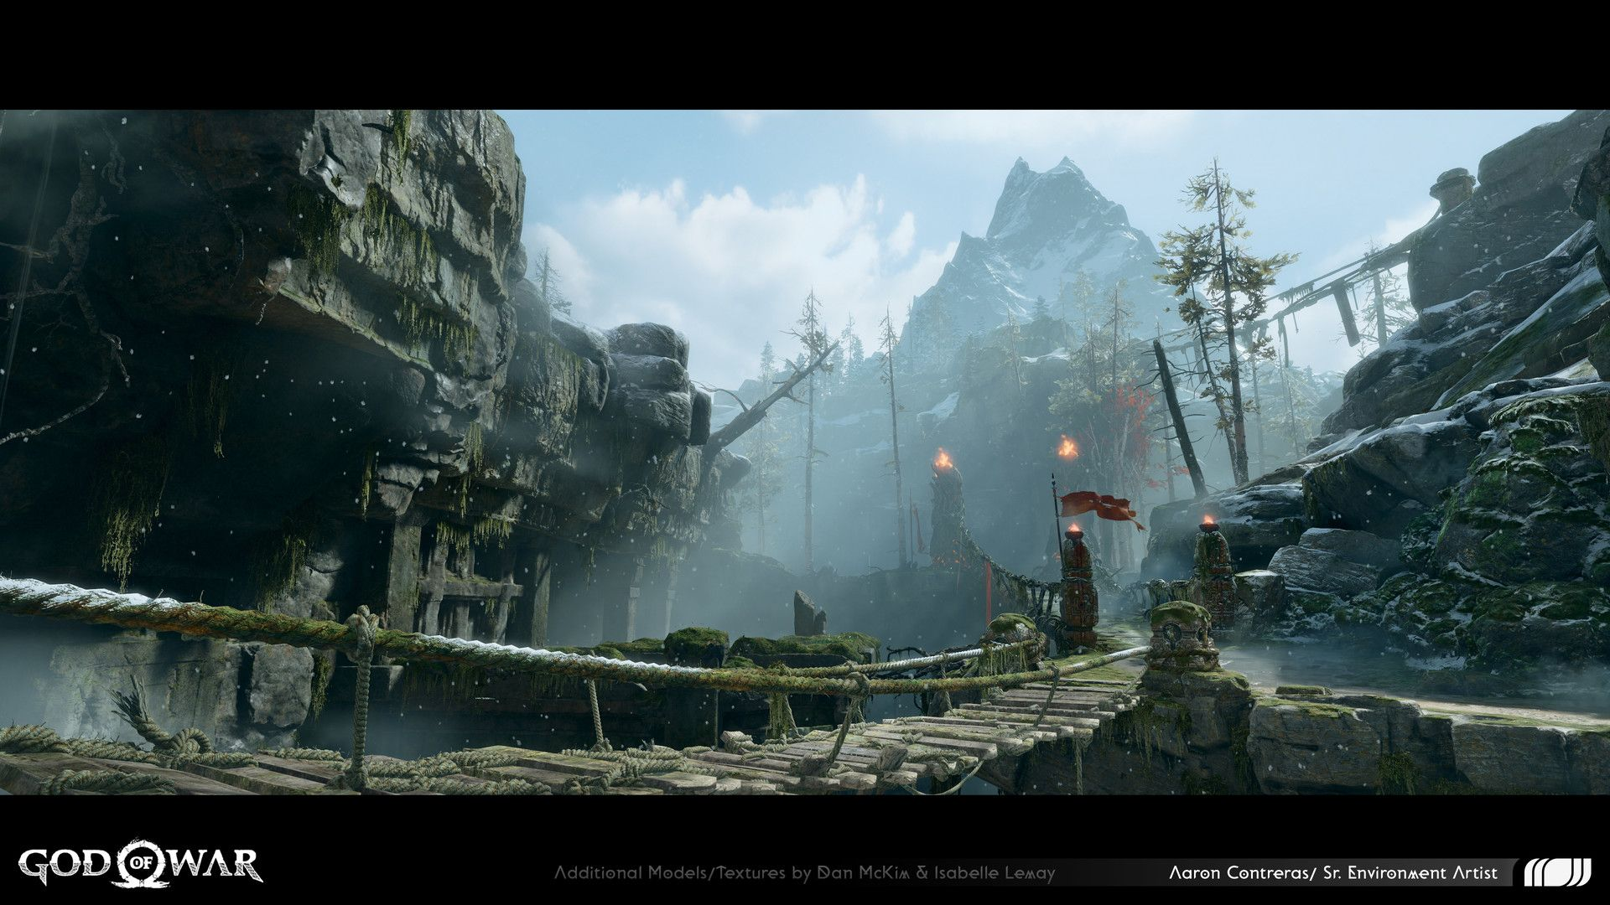

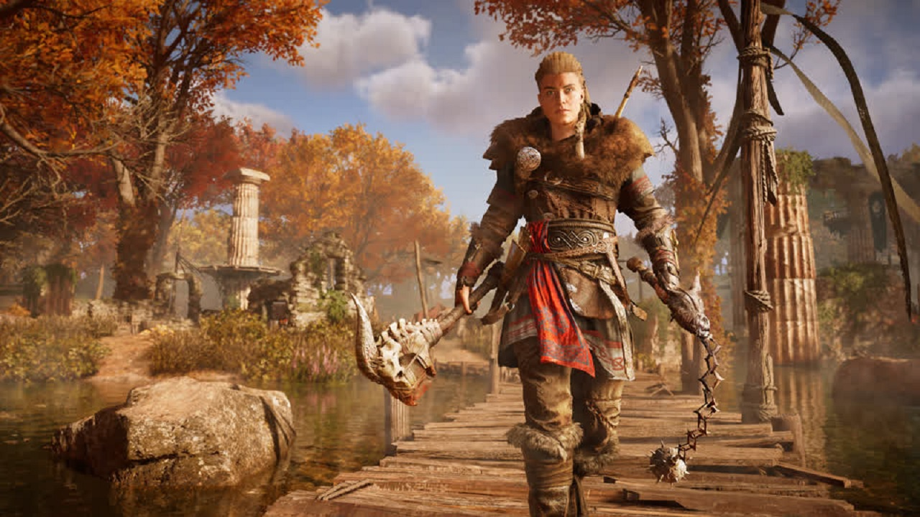

#### 4.3 Assassin's Creed.

**The Assassin's Creed franchise is one of those series that takes a simple concept roaming a city, that give you the feeling of 1700 feeling.**

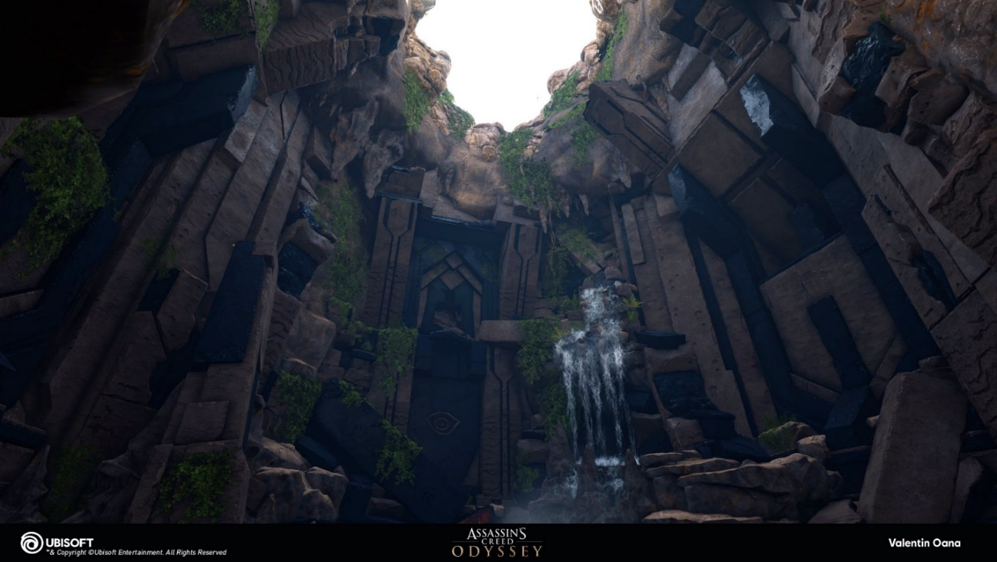

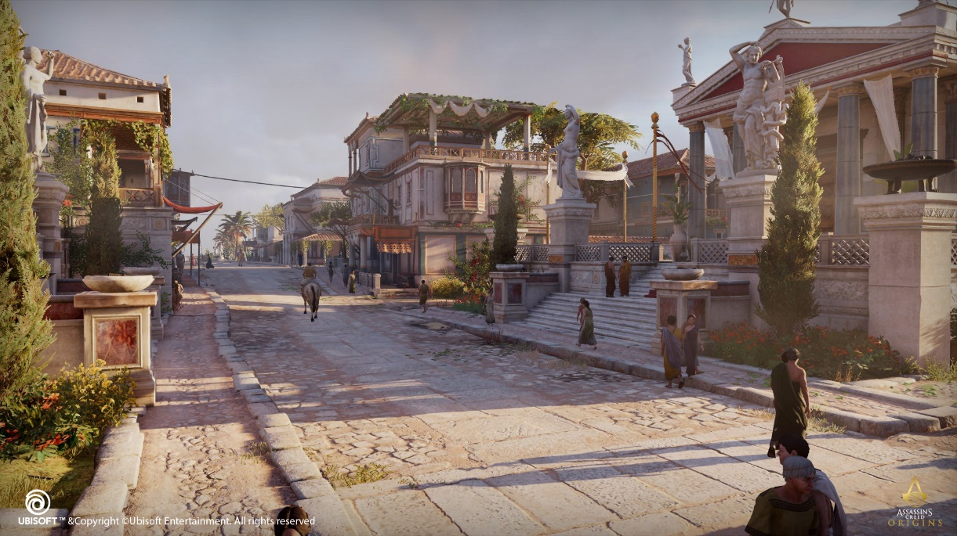

**A city whose road are paved with rocks and the main medium of transportation is horse.  
The stone are shaped like a lamp for the fire for the night time.**

## 5 Summary and Conclusions

After conducting various research and reviews on 3D environment of games . I have decided that I will be modelling the environment in 3D and animating a simple thing on the environment, I will be using Maya for modeling and blender for sculpting and substance painter for texturing the gaming environment.  
  
My main focus on this project is to design natural environment with the help of simple modeling process. With the help of Supervisors I can create a good gaming environment for this module.

I'll try to incorporate most of my research into this project. With the inspiration and ideas gained from similar animations, I aim to create a captivating animation that follows a specific style that the audience will find interesting.

## Refernce

**3D modeling Image:** [**https://ev111426.files.wordpress.com/2014/10/3d-model.jpg**](https://ev111426.files.wordpress.com/2014/10/3d-model.jpg)[**https://www.mixamo.com/images/panel2.jpg**](https://www.mixamo.com/images/panel2.jpg)

**Sculpting Vs Modeling.**

[**https://inspirationtuts.com/3d-modeling-vs-sculpting-whats-the-difference/**](https://inspirationtuts.com/3d-modeling-vs-sculpting-whats-the-difference/)

**High Poly and low poly Modeling.**[**https://www.modelry.ai/blog/difference-between-high-poly-and-low-poly-models**](https://www.modelry.ai/blog/difference-between-high-poly-and-low-poly-models)

**Product review images:**

**Assassins Creed:**[**https://cdna.artstation.com/p/assets/images/images/013/430/062/4k/valentin-oana-cyclops-brokencavern1.jpg?1539584477**](https://cdna.artstation.com/p/assets/images/images/013/430/062/4k/valentin-oana-cyclops-brokencavern1.jpg?1539584477)

